Mobile Agents Diagram

By Connor Frost and Gavin McGuire

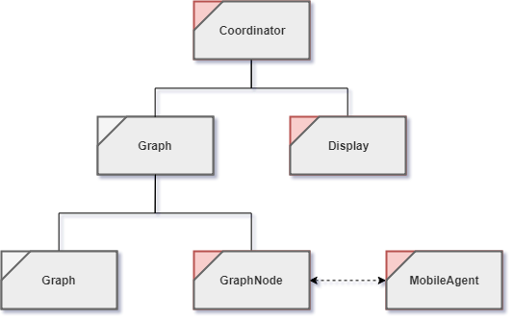

Diagram Explanation

# Coordinator

The Coordinator, (otherwise described as Main within the context of the application), calls the many different subroutines to create a functioning emulation of Mobile Agents in the context of a JavaFX GUI-based application.

Allows for user to be prompted with what files they would like to enter for the application and have the option to use files outside of those already defined by the test files. When a configuration is selected, the coordinator creates an instance of the graph with the configuration in mind, displays the emulation, and starts the Mobile Agent’s behaviors

# Graph

The Graph acts as the moderator between the coordinator and the individual nodes to contain the various graph elements. The graph object serves the following purposes.

* Creates the nodes from the selected configuration file
* Allows threads of the independent nodes to be started from a centralized location
* Contains the GraphNode elements in a Map, to allow easy access when creating the graph structure.
* Contains the edges of GraphNode

# Display

The display has two distinct components that allow an easy transition between the loading screen and the screen containing the emulation.

## Selection screen

The selection screen is the screen that works with the coordinator in order to gather all the information needed to begin the emulation.

## Emulation screen

The emulation screen relies on the references held within the Graphical devices to draw themselves onto the screen. From there the elements can be updated by color and provide a emulation-like experience to the user.

The emulation follows after the user selects a configuration file, and is enabled by the references passed into the

# GraphNode

GraphNode is the underlying component that communicates with the Mobile Agent and other GraphNodes on separate threads to emulate a file/messaging system. GraphNodes serve the following purposes:

* Spread the fire among other Graph Nodes
* Communicate with other GraphNodes to convey messages to the base station
* Communicate with the attached Mobile Agent to gather messages

## Base Station

The base station is designated as a boolean value. Only the designated base stations have the ability to output messages to the log. Other base stations will be able to print, but only by using the base station as a proxy.

# Graph Edge

Graph Edges form the connections between the Graph Nodes for which the fire spreads through. These logically link GraphNodes from one to another. The graph edge communicates with the display to visually draw it within the emulations.

# Mobile Agent

Mobile Agents are started with a random walk until it reaches a fire, and then the Mobile Agent attaches itself to the GraphNode that it is assigned to monitor. The Mobile Agents serve the following purposes in the context of the object design.

* Communicate with the GraphNode to log messages
* Communicate with the display, to visually display the Mobile Agent as a ring around the GraphNode